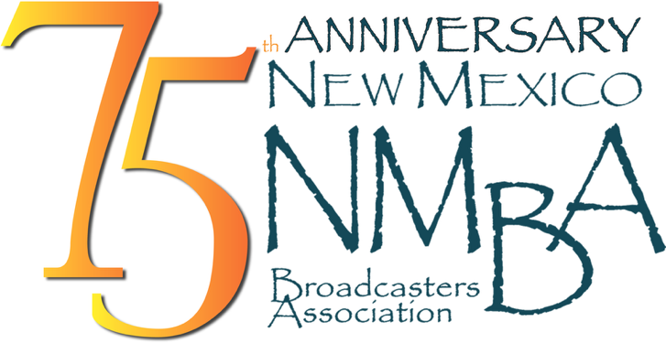

Insertion Order
NMDOT/ Traffic Safety Division
Distracted Driving & Underage Drinking

Date: August 25, 2026

Client: NMDOT Traffic Safety Division
Media: TV
Length: 30 – Rotate Equally

ISCI Codes: TSDD2223 – Distracted Driving
DOT Distracted Driver
https://drive.google.com/file/d/1QgZ6Whwm7sQxaQB9AzYQK_eGAoQ1UrpW/view?usp=sharing

TSDU2224 – Underage Drinking
DOT Underage Drinking
https://drive.google.com/file/d/11hV7O6Um2R6YTrIsp-8gBNDs-7hkiKC0/view?usp=sharing

Air Dates: ASAP – May 31, 2026

Number of times per week: 3x

Dayparts: 5:00 A- 12:00 M Monday thru Sunday

Please forward all invoices:
Mail to the NMBA or email PDF or Excel file to davina@nmba.org or remit affidavits through Adcore, Marketron Exchange, or Radio Invoices.com
Please confirm receipt of this insertion order to
davina@nmba.org

**Notarizing of invoices NOT required

