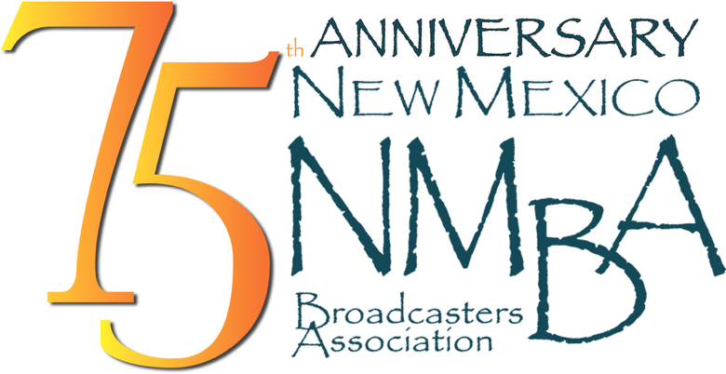

PEP TV Insertion Order: TKO on behalf of the W.K. Kellogg Foundation

Date: June 1, 2026

Client: – Pass the Sopapillas

Media: NM TV

Length: 30 - ISCI codes

ISCI Code: WKKF2250 -English

https://www.dropbox.com/scl/fi/prnuaflhe8e7bqb8lhz28/PodCastAd-Final-V004.mp4?rlkey=lg4pjffur14268eke9ucd1civ&st=4d513yu8&dl=0

Air Dates: June 1, 2026 – August 31, 2026

Number of times per week: minimum 3x

Day parts: Mon-Sun 5:00A- 12:00M

Please forward all invoices** to one of the following:
email PDF to davina@nmba.org or remit affidavits through Adcore, Marketron Exchange, or Radio Invoices.com

Please confirm receipt of this insertion order to davina@nmba.org

**Notarizing of invoices NOT required

