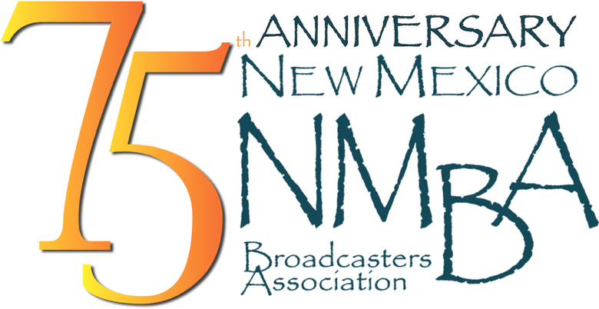

PEP Radio Insertion Order: TKO on behalf of the W.K. Kellogg Foundation

Date: June 1, 2026

Client: – Pass the Sopapillas

Media: Radio

Length: 30 - ISCI

ISCI Code: -English WKKF2110
https://drive.google.com/file/d/1sLgF-_HFWcY6lL2WDjLEBrlu3G80cSDZ/view

Air Dates: June 1, 2026 – August 31, 2026

Number of times per week: minimum 3x

Day parts: Mon-Sun 5:00A- 12:00M

Please forward all invoices** to one of the following:
email PDF to davina@nmba.org or remit affidavits through Adcore, Marketron Exchange, or Radio Invoices.com

Please confirm receipt of this insertion order to davina@nmba.org

**Notarizing of invoices NOT required

